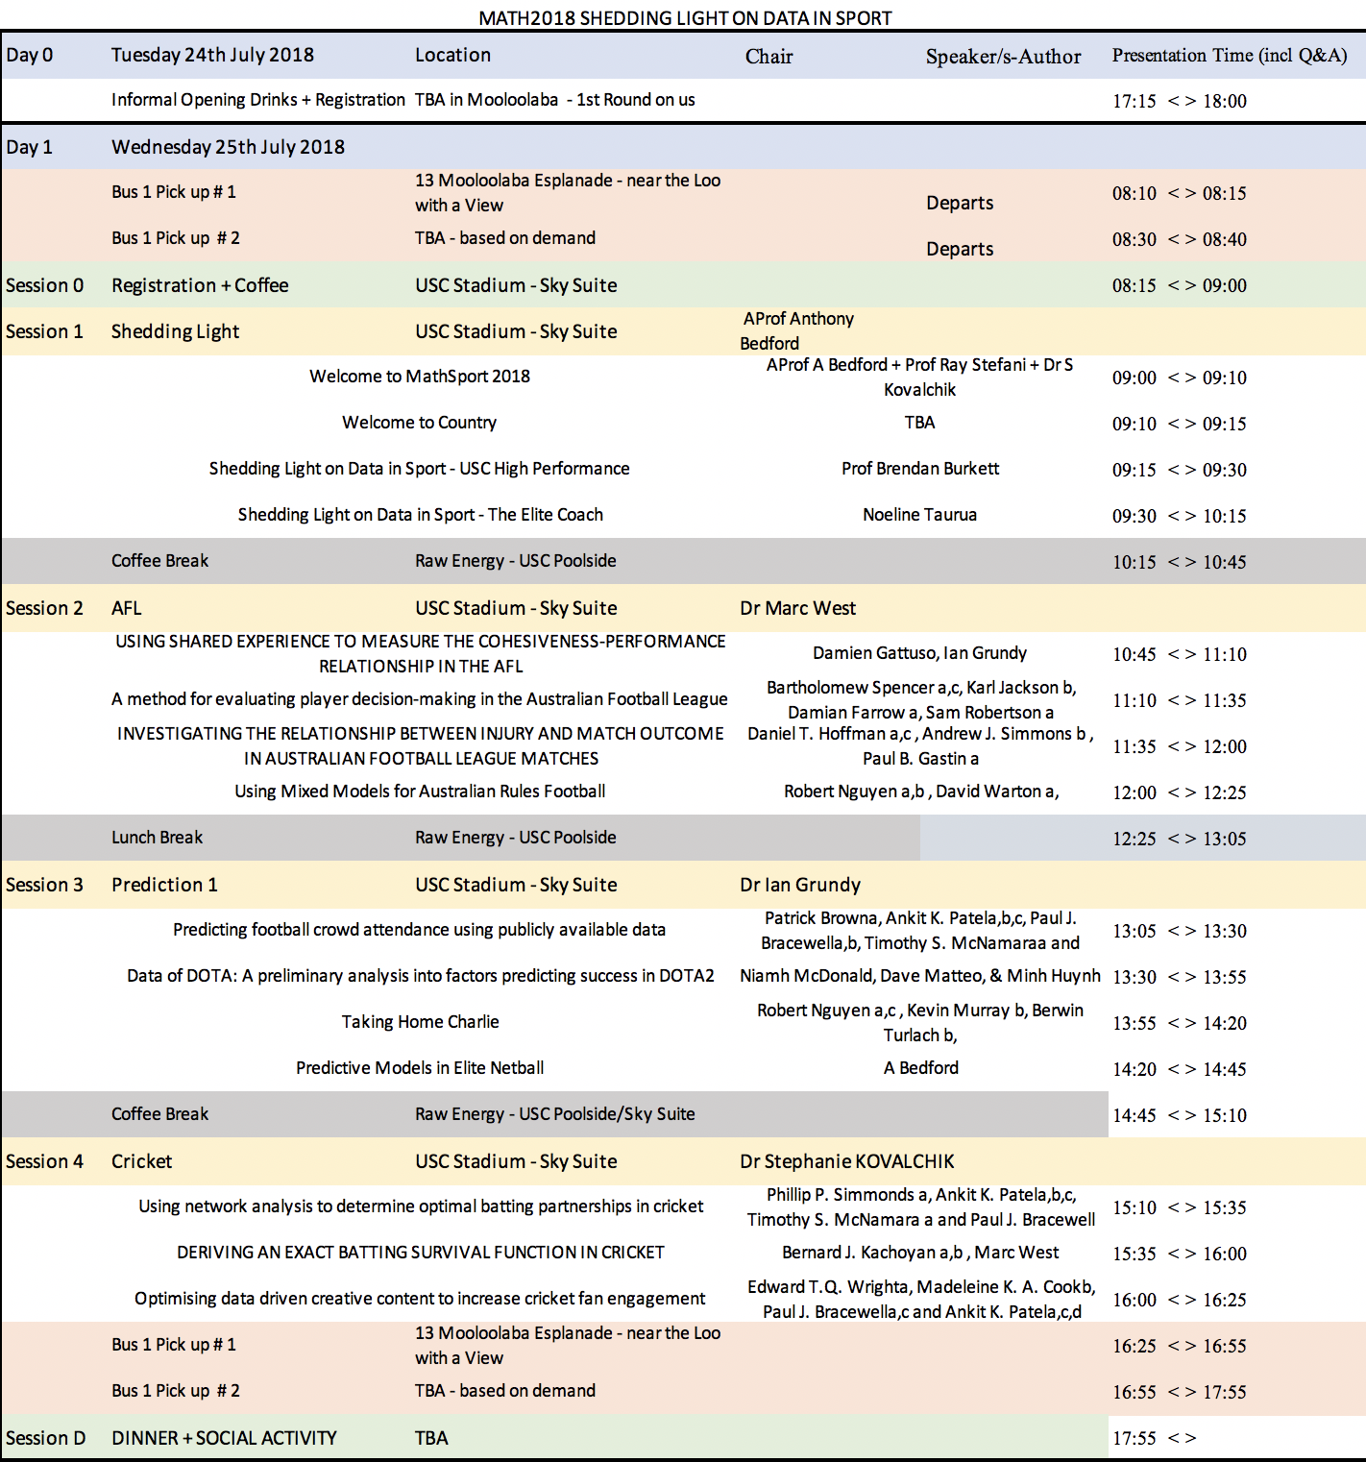
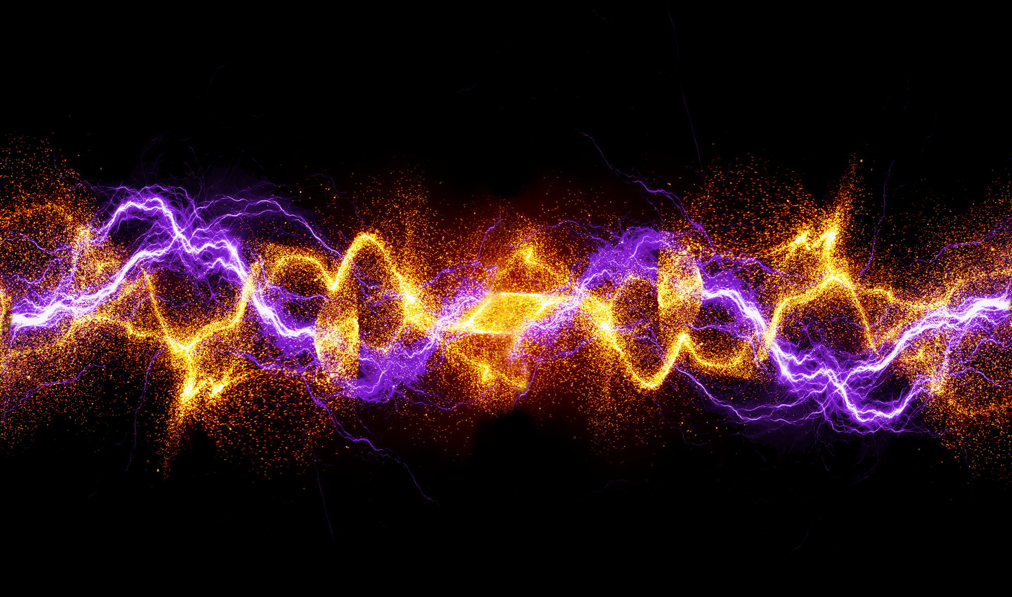

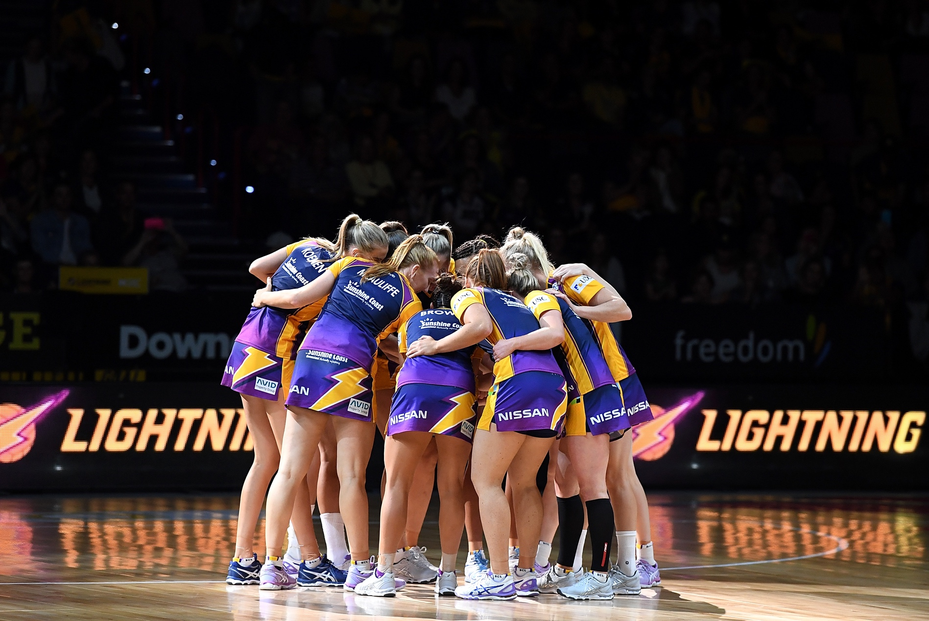

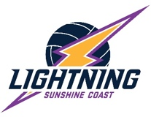

CONFIDENTIALITY
IMPORTANT NOTICE
Results and findings contained within this work refer to confidential information. The author gives permission for the distribution of this report by Sunshine Coast Lightning only. This report and its findings must be treated in the strictest confidence and not distributed or reproduced without the permission of Sunshine Coast Lightning.

